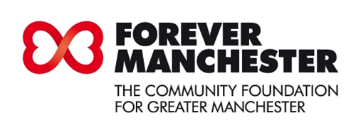
Golf Challenge 2015 Entry Form

HIGH LEGH PARK GOLF CLUB – Warrington Road, High Legh, Knutsford, Cheshire WA16 0WA
Thursday 14th May 2015 – Refreshments at 9.30am, Shotgun Start at 10am
plus
Prize Presentation Buffet

COMPETITION RULES AND CONDITIONS

Competition: Four Man Team

Entrance Fee: £300.00 per team (4 Player) including refreshments.

Dress Code: Smart golf attire.

Organiser: Alan Townley
Contact: 07703 854809

The Forever Manchester Charity Golf Challenge will feature:

- 18 holes of Golf

- Competitions – (e.g.) Nearest the Pin – Longest Drive
- Overall Winning Team Trophy – The Forever Manchester Trophy
(plus miniature replicas for winning team members)

- 2nd , 3rd placed team prizes

- Buffet

- Charity Raffle

Reservation Details

Team name:

Name of main contact:

Address:

Postcode:

Tel:

Email:

I wish to enter a team of 4 players at £300.00 per team

Name of Player Handicap

1

2

3

4

Play starts at 10am (Shotgun Start)
Payment options:

To ensure that the maximum amount of money raised through the event comes to the charity, and does not get lost in booking fees incurred when using online payment systems, we are recommending the following payment options:

By cheque:
Payable to ‘Forever Manchester Donations’ to be sent along with completed booking form to: Cheryl Hill, Golf Challenge, Forever Manchester, 2nd Floor, 8 Hewitt Street, Manchester M15 4GB.

By BACS:
You can make payment by BACS into Forever Manchester Donations Account, Sort Code: 08-90-00, Account Number: 65498356.

You can forward your email and booking form to cheryl@forevermanchester.com or print out your email and booking form and return to: Cheryl Hill, Golf Challenge, Forever Manchester, 2nd Floor, 8 Hewitt Street, Manchester M15 4GB.

Cancellation Policy:
If for whatever reason you decide you can no longer attend the Golf Challenge, please let us know in writing as soon as possible and no later than 2nd May 2015 so that we can allocate your places to someone else.

If you inform us within this time frame we will issue a full refund, however, if you fail to let us know by 2nd May 2015 we will take full payment for the tickets and will not be able to issue any refund.

